BLM 305 Midterm Examination Nov. 18, 2015
(Duration: 90 minutes. One sheet of notes allowed. No exchange of materials)

1. Consider the class definition and the variables shown below
1a 15
1b 15
1c 10
1d 15
1e 10
2 35

class Point { // this class is not related to java.awt.Point
final int hour, minute, time;
Point(int h, int m) {

...

}
public int hashCode() {

return ...
}
public boolean equals(Object x) {

return ...
}
public String toString() { // such as "9:00"

return ...
}
}

class Activity {
String name; Point start, end;
public Activity(String n, Point s, Point e) {
name = n; start = s; end = e;
}
public int duration() {
return end.time - start.time;
}
public String toString() { // such as "walk 8:25-9:00"

return ...
}
public static Point makePoint(int h, int m) {
return new Point(h, m);
}
final static Point p = makePoint(8, 25);
final static Point q = makePoint(9, 0);
final static Activity y = new Activity("walk", p, q);
final static Point[] a = { p, null, p, q };
public static void main(String[] args) {
System.out.println("Sample Activity\n"+y);
System.out.println("Duration = "+y.duration());
}
}

a) Fill in the blanks indicated by “...” within the code above
Note: time indicates number of minutes since midnignt
new Point(1, 20) should be equal to new Point(0, 80)
b) Draw a simplified object diagram for a, p, q, y

c) Show the necessary modifications so that Point objects can be added to a TreeSet

d) Show how to make a list from the array a

List<Point> L = ...

Show two ways of making a set from the list L

Set<Point> s = ...

Set<Point> s = ...

If a.length is 1200, what can you say about the size of L and the size of s?

e) Show three ways of defining c, the actual class of object L
Class c = ...

Class c = ...

Class c = ...

2. Consider the class definition and the variables shown below

class Midterm implements Runnable {
static Thread one, two;
String name;
Midterm(String s) { name = s; }
public void run() {
delay(700, name);
}
static void delay(int d, String n) {
System.out.println(n +" begins");
long s = System.currentTimeMillis();
try {
Thread.sleep(d);
} catch (InterruptedException e) { }
long t = System.currentTimeMillis();
System.out.println(" "+one.getState());
System.out.println(n+" ends in "+ (t-s));
}
public static void main (String[] args) {
one = new Thread(new Midterm("one"));
two = new Thread(new Midterm("two"));
one.start();
delay(300, "main");
two.start();
}
}

a) Explain why this program writes exactly 9 lines

b) Draw a time-line showing when each thread begins and ends

c) Predict the output and the total runtime of this program

d) What makes this class Runnable?
Consider the class definition and the variables shown below

class Counter implements Runnable {
static Counter one; static Counter[] Y;
String name; int cnt; Thread thd;
public Counter( ... ) {
name = s; cnt = n;
thd = new Thread(this);
}
public void run() {
while (cnt > 0) try {
cnt--; Thread.sleep(500); //wait for 0.5 sec
} catch(InterruptedException e) { }
report();
}
public void start() { thd.start(); }
public void stop() { ... }
public void report() {
System.out.println(one.thd.getState());
}
public static void main(String[] args) throws ... {
one = new Counter("bir", 4); one.start();
Thread.sleep(1000);
two = new Counter("iki", 6).start();
one.report();
}
}
a) Fill in the blanks indicated by “...” within the code above
b) Draw a simplified object diagram for one and Y
c) Draw a time-line showing when each thread begins and ends
d) Predict the output (exactly 3 lines) and the total runtime of this program
e) Show how to make array Y from List<Counter> L with 2000 elements
f) Show how to make a Set S from the List L
g) What can you say about the size of the array and the size of the set?

CSE 470 Quiz Oct 22, 2015
(Duration: 25 minutes. One page of notes is allowed. No exchange of materials)

enum Month { Jan, Feb, Mar, Apr, May, Jun, Jul, Aug, Sep, Oct, Nov, Dec }
class Date {
int day; Month mon; int year;
public Date( ) {

}
public String toString() { // “Jan 1, 2105” for p
return ...
}
}

1. Complete the blanks shown above so that the following code is correct.
Date p = new Date(1, Month.Jan, 2015);
Date q = new Date(9, Month.Jan, 1983);
Date[] a = new Date[5];
a[0] = p; a[2] = p; a[3] = q;

2. Complete the object diagram for the three objects defined above:
Write down class names of each object, field names, field values, and missing arrows.
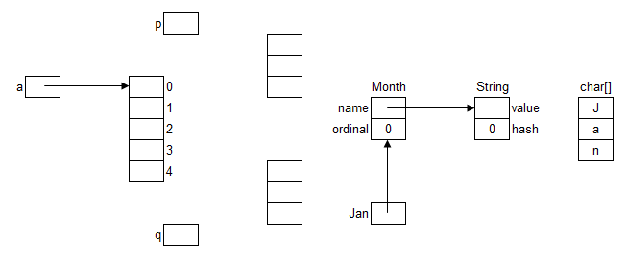
3. Show how to make List b using a, and Set h using b

List<Date> b =

Set<Date> h =

4. Show how to get the first element of a and b. (write two lines of code)

5. Show how to set the last element of a and b to the object reference q.

6. Predict the values of h.size() and h.contains(p)

